Print:
Data:
- Numeric Data ( * Integers Value * Floating point)
- Text data ( All the Text are #String value )( Every data in (“”) are string data also Numbers)

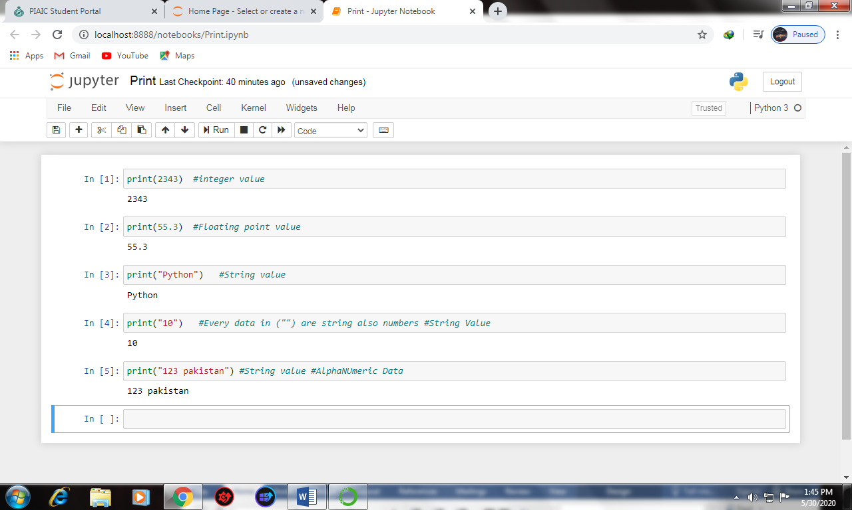

Sep: (Separator)
- After (,) print function #sep use his own space
- If I want to use space or any Sign between texts I can use #sep function.
Example: 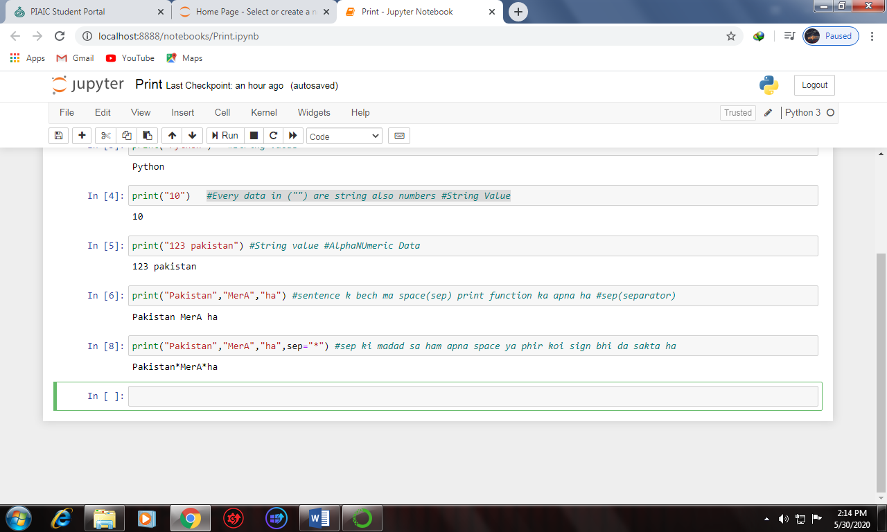
End:
- End function is used for separating words on next line or Spacing with Tab.
Example: (Escape Character)
1) end=”\n” (For next Line)
2) end=”\n\n” (For spacing in next line)
3) end=”\t” (for spacing with tab in same lines)

